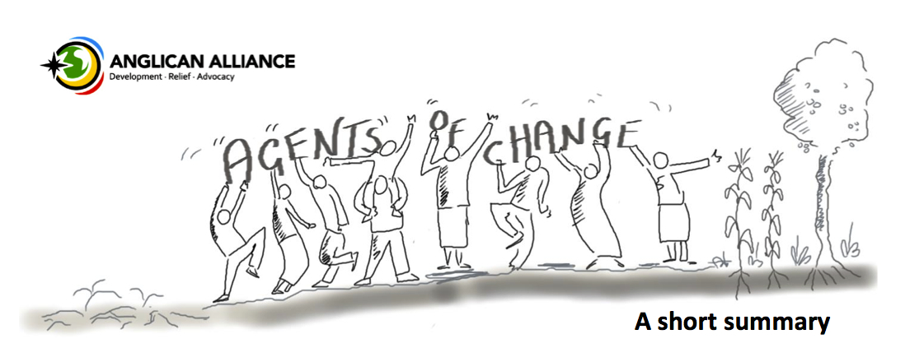

“The Agents of Change programme is one of the most exciting innovations from the Anglican Alliance. The modules focus on vital areas of community development, grounded in academic rigour. It is a superb contribution from the Anglican Alliance to strengthen the committed and inspiring work of Anglicans around the world in holistic mission.” Most Revd Justin Welby, Archbishop of Canterbury

What is Agents of Change?
Agents of Change is a programme of the Anglican Alliance to help Anglicans anywhere in the world tackle poverty and bring about transformation in their local communities.

The course equips participants with the skills and knowledge needed to set up a development project in their local community. It looks at every stage of the process - from coming up with an idea… to planning… to managing a project… to monitoring it and evaluating it. The course teaches both practical skills (such as how to write a budget and how to do a risk assessment) and values (such as being inclusive and being transparent).

Agents of Change is a distance-learning course. There are 8 modules, which participants study at their own pace with the support of a mentor. At the end of each module, participants send their work by email to their mentor for comment and feedback. On successful completion of the course, participants are awarded a certificate in recognition of their work and achievement, but more importantly, they are equipped to become Agents of Change in their communities.

Teaching best practice
The course modules have been developed to ensure that local community-based programmes provided as part of the Church’s mission are designed and delivered in accordance with best development practice, as currently understood. The topics covered by the modules have been chosen because experience shows that when projects fail, it is usually because one or more of these areas was not adequately thought about.

Module 1: Dreaming dreams  - Serving the wider community: the Anglican 5 Marks of Mission  - Looking at your community in depth: mapping, assets and challenges.  - Identifying your community’s assets  - Problem and solution trees.  - Dreaming dreams.  - Coming up with a project idea. | Module 2: Consultation  - What is consultation?  - Why is consultation so important?  - Who should be consulted?  - What is good consultation? What is bad consultation?  - How should a consultation be carried out and what do you do with the results of consultation?
Module 3: Planning  - Defining your project  - SMART objectives  - Making an action plan  - What resources will you need?  - Estimating costs  - Preparing a budget | Module 4: Inclusion  - What do we mean by inclusion and exclusion? Why is inclusion important?  - Commonly excluded groups.  - Who is excluded in your community?  - How to plan a community census  - Enabling participation
Module 5: Protection  - What do we mean by “vulnerability”?  - Hazards, threats and risk factors  - Making sure your project does not unintentionally cause harm  - Safeguarding  - Risks assessments | Module 6: Governance  - What do we mean by “governance”?  - What is good governance? Why does it matter?  - What does bad governance look like?  - Stakeholders  - Being aware of power and using it well.
Module 7: Finance  - Financial accountability  - Patronage and power  - Practical tools for record keeping and budget monitoring  - Finding funds for your project: looking to your own resources; dangers and practicalities of external funding | Module 8: Project Management  - Work monitoring  - Managing change  - Working with volunteers  - Evaluating your project  - Handover / completion of the project  - Self-development

Planning a project for your community
As you go through the course you will plan a project for your community. It can be anything you choose. For example, you might want to plan a literacy class, or a nursery, a savings and loans association or a community health project. You might already have an idea for the community project you want to work on. If this is the case, the first module will help you test your idea. But you might not yet have a project idea. Don’t worry – that’s fine! The first module will help you to come up with one.
As you work through the course modules you will develop your initial idea into a fully thought-out plan. The main purpose of having your own project to work on is to focus your learning and bring it to life. However, at the end of the course, you will have a blueprint for your project – a plan that you might feel God is calling you to put into action.

What do we mean by a “development project”?
When we talk about a development project we simply mean setting up an activity that benefits the whole community, makes life better for people, tackles poverty, transforms lives, demonstrates creation care, empowers people or in some other way expresses God’s love and reflects Jesus’ words, “I have come that they may have life, and have it abundantly” (John 10:10).

Examples of development projects worked on to date by Agents of Change participants include: a piggery project to generate income for a rural community with high unemployment, a motorbike ambulance project to help people in remote rural areas access health centres, a school leavers’ club to help young people move on to employment, a community beautification scheme, a vegetable garden to provide food and income for a women’s refuge and a tree nursery to help address problems of deforestation.

An “assets-based” approach
Agents of Change takes an assets-based approach and is designed to be compatible with other assets-based community development approaches such as Umoja or Church and Community Mobilisation.

What does “assets-based” mean? Traditional approaches to development have often focused on a “problem”, “need” or “challenge” that a “project” is set up to correct. Often, the “need” is identified by someone from outside of the community and, usually, the project depends on outside (“donor”) funding. This can be very disempowering for the community, even if they benefit from the project itself. This is because such a needs-based approach focuses only on what the community DOES NOT have, rather than balancing this with looking at what the community DOES have – and using it. Increasingly, the Church is moving towards “Assets-Based Community Development”. This is where communities are the agents of their own change. Together, communities look at both their challenges and their assets (capabilities, resources, skills and experience). Together, communities decide on their priorities for change, come up with project ideas and plans and put them into practice using the community’s assets – often without outside help or funding. This assets-based approach is far more empowering and sustainable.

What do participants say about Agents of Change?
“Agents of Change made me realise that the passion I had to save the community can come true. … Thank you very much for this opportunity to study Agents of Change. This is a very good programme, which can change the way we manage projects in the Church as well as in the communities.”
Isaac Ndhlovu, Zambia - the first graduate from the course.

“It’s a tool to get the right knowledge at the right level and on the right focus area into a community, to help change take place in people’s livelihoods.”
Dennis Kabekabe, Solomon Islands.

“I have always wanted to be an Agent of Change but never knew how!! This course is important to me because it has equipped me with skills necessary to undertake a project in my community that can change lives. This world is full of disappointments, persons are crying out that the church is not playing its role and if I can be the change I want to see and save lives through the Holy Spirit what better reward can there be? This course has given [me] the motivation and resilience to make change.”
Gabriela Kydd, St Vincent, Windward Islands.

If you would like to find out more about Agents of Change, please contact the course coordinator Dr Elizabeth Perry
elizabeth.perry@anglicancommunion.org

